

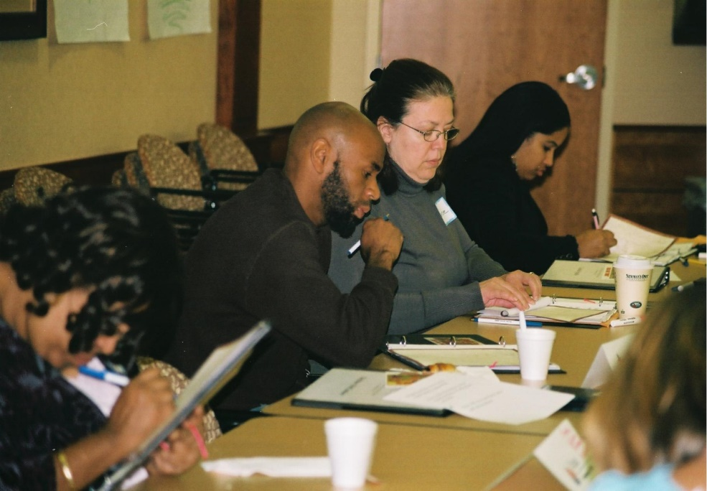

**The Four Core Beliefs of Parents SEE:**

* All children can achieve at high levels and meet high standards.
* Our society has the responsibility to educate all children.
* Parental involvement in education is essential to student success.
* Informed civic engagement makes

schools better and helps children

achieve at higher levels.

“The course gave me confidence, resolution, personal growth opportunities (previously not known) and the inspiration we get from each other to do more.”

*Bristol Parents SEE graduate*

“It’s an eye-opening experience; I have not only learned more about the school system, I have also learned more about my community as well as myself and what I can do to make a difference.

*Stamford Parents SEE graduate*



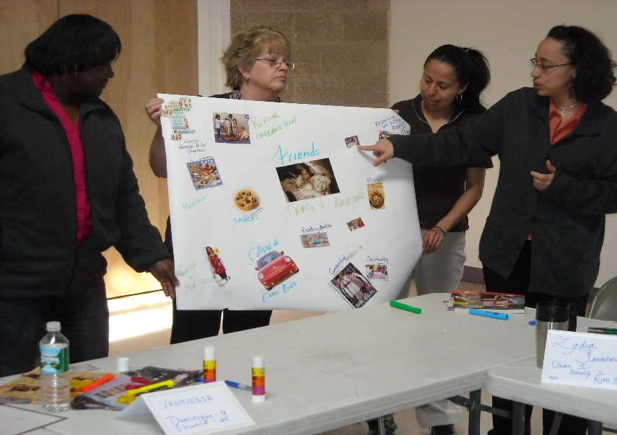

**For information regarding PSEE in Windsor, contact Maureen Bilotta,** [**mbilotta@windsorct.org**](mailto:mbilotta@windsorct.org)

**860-687-2000 ext. 232**

**Parents SEE was developed**

**and is offered by:**

**Connecticut Commission on Children**

***and***

**Connecticut Center for School Change**

**For further information please contact:**

**Patrice Nelson**

**Parents SEE Statewide Coordinator**

151 New Park Avenue, Suite 203

Hartford, CT 06106

860-586-2340 Phone

860-586-7360 Fax

**pnelson@parentssee.org** *Email*

<http://www.ctschoolchange.org/what-we-do/impact-areas/developing-leadership>

*Doc.612-012413*





**Leadership**

**Change**

**Educational Policies & Practices**

**Partnering**

A FREE civics leadership initiative

providing strategies and tools to prepare parents, grandparents and guardians to partner with schools, to improve education for all children.

***What is Parents Supporting Educational Excellence?***

* It’s a chance to make a difference for children and for their schools.
* It’s a place to engage in dialogue and practice skills needed to effect constructive change.
* It’s an opportunity for parents to acquire knowledge to become leaders, change agents and active participants in education.



***Why Do We Do It?***

* Research shows a clear link between student achievement and parent/family engagement.
* Students are more successful when schools, families and communities work together.
* Parent engagement at home, at schools, and in communities really does make a difference.



***How Do We Do It?***

* Participants explore Leadership, Change, Educational Policies and Partnering.
* School leaders attend as guests, facilitating dialogue and policy partnerships.
* Parents acquire skills to address public policy issues and engage as civic leaders to improve schools for all children.

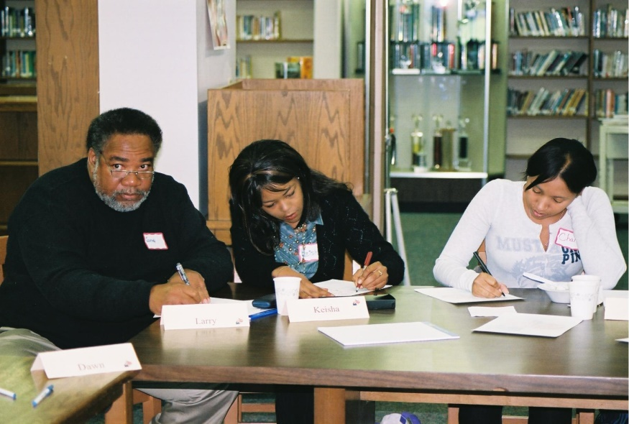

***Who Participates?***

* A coordinator and design team recruit and select parents.
* The design team and the parents reflect the diversity of the community.
* Parents are engaged while a local civic design team oversees program implementation.

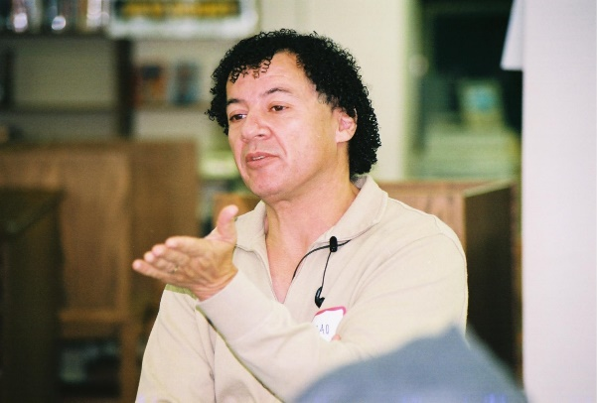

***The Curriculum Outline***

* *FREE COURSE*
* Three-hour morning retreat on a Saturday, and 12 Tuesday evenings from 5:00-8:30 p.m. with dinner.
* Child care and transportation stipends are provided as necessary.
* Continuing Education Credits (CEUs)

are offered by the Connecticut State Department of Education.

|  |  |
| --- | --- |
| **SESSIONS** | **TOPICS** |
| **Retreat**  **Saturday, 1/21/17** | Getting started and course overview |
| **Tuesday - 1/24/17** | What do effective schools look like? |
| **Tuesday - 1/31/17** | What is change? |
| **Tuesday - 2/7/17** | How and why do schools change? |
| **Tuesday – 2/14/17** | Why do some students succeed in school while others do not? |
| **Wednesday -2/22/16** | How does your school district function? |
| **Tuesday - 2/28/17** | What is a citizen’s/parent’s role in how the school district functions? |
| **Tuesday - 3/7/17** | What is a parent’s role in children’s learning and school improvement? |
| **Tuesday - 3/14/17** | What is our educational system? |
| **Tuesday - 3/21/17** | When are improvements in schools warranted? |
| **Tuesday - 3/28/17** | What are key education policies? |
| **Tuesday - 4/4/17** | How do parents lead in schools? |
| **Tuesday - 4/18/17** | How does understanding and a civic tool kit lead to effective parent leadership in education? |
| **Graduation** | Date to be determined |

***Coming Soon to Windsor***

***Sessions held at***

***J.F. Kennedy School, 530 Park Avenue***

***STARTING: January 21, 2017 – Retreat***

***Evening Sessions begin January 24***

***For more information contact: mbilotta@windsorct.org***