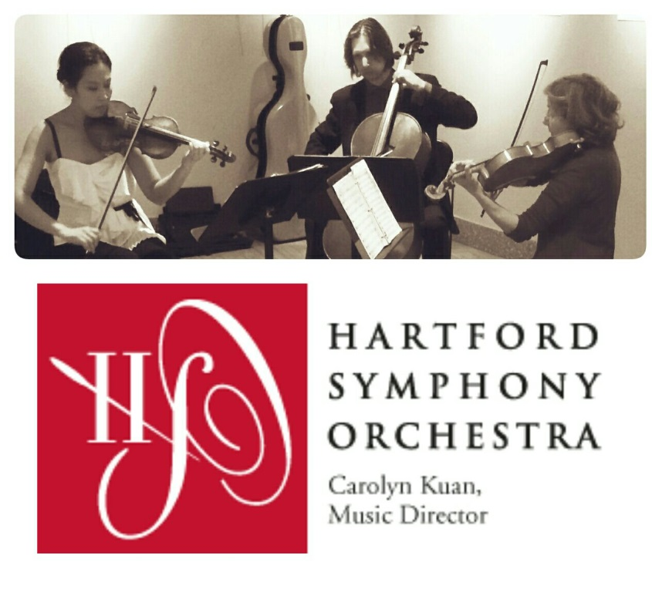
The Music School at Sound Crossing Presents

The Mosaic String Trio
Thursday, July 14th at 11:30 a.m.
at the
Poquonock Community Church
1817 Poquonock Ave., Windsor

Lu Sun, Violin
Pat Vance, Viola
Peter Zay, Cello

FREE! Optional donation to benefit The Music School at Sound Crossing

Join us for this interactive community concert featuring musicians from the Hartford Symphony Orchestra. All ages welcome! The Mosaic String Trio uses literature, music, and art to explore how we express ourselves. The ensemble will perform a mix of music by Bach, Mozart, Beethoven, and Schnittke, and a diverse mix of cultural, folk, and popular music. The program is enhanced with a PowerPoint presentation that showcases the world’s great masterpieces of art, architecture, and literature. Students will have the opportunity to ask questions and participate as music makers on rhythm instruments with the ensemble. Please bring a lunch to enjoy from 11:00-11:30 a.m.

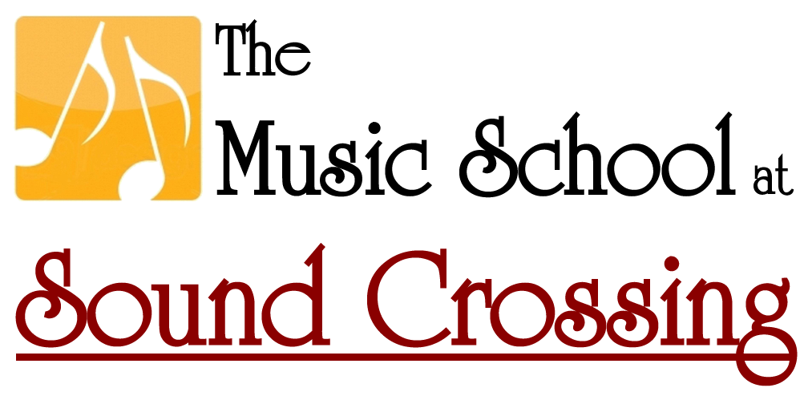
1817 Poquonock Ave. Windsor, CT
860-688-7707
www.soundcrossingmusic.com

