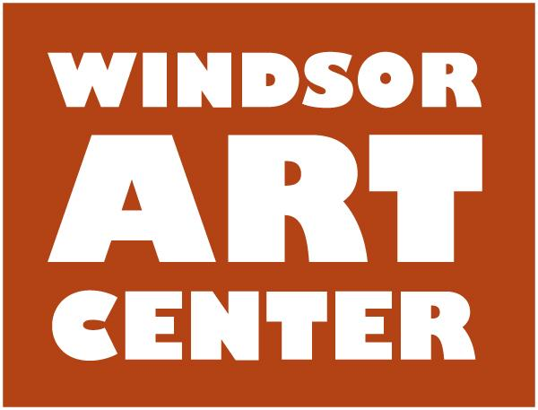
Press Release Contact: Christine MacClintic
Immediate - Thursday, December 8, 2016 860-752-9539

WINDSOR, CT. - The Windsor Art Center is excited to be hosting a photography show entitled The Human Condition: New York City Humanity, on Saturday, January 14, 2017. The two Photographers featured in this exhibition are William Butcher and Jacob Murphy. Both artists live and work in New York City and, combined, their work boldly illustrates the contrasts and perspectives of our humanity and individuality.

The exhibition opens with a free public reception on Saturday, January 14, from 5:00 - 7:00 pm, with a musical performance by Austen James and The Heavy Calm following the reception at 8:00pm. The Heavy Calm is an atmospheric, euphoric indie rock experience. Soaring guitar lines, sweeping melodies, and dynamic swells dominate the music, www.theheavycalm.com. A snow date is planned for January 15 from 5-7 pm. The exhibition runs through February 25 at The Windsor Art Center, 40 Mechanic Street, Windsor, CT.

An Artist Talk presented by both the artists will be held on Saturday, January 21, from 2:00 - 3:00 pm. Gallery hours are: Thursday, 6:00 - 8:00 pm; Saturday, 10:00 am - 4:00 pm and Sunday, 11:00 am - 4:00 pm.

Due to the social consciousness theme of this show the Windsor Art Center will be accepting non-perishable food donations at the opening, as well as throughout the exhibit, to be donated to the Windsor Food Bank in the artists’ honor.

Additional events during the exhibition:

Saturday, February 11 • 2-3pm • Jiayi He Hermonica concert
Tickets: $20 general admission.

CT Guitar Society Windsor Winter Series:
Sunday, January 15, 2017 Frank Varela in Concert 2:00 pm
Sunday, February 5, 2017 Sinan Bakir in Concert 2:00 pm
Sunday, February 19, 2017 Jason Jenkins in Concert 2:00 pm
Tickets for individual concerts: $20 general admission; $15 CGS members. htt://ctguitar.org/.

This exhibition is made possible by the generous support of Dan J. & Alice Ford Ferraina, and from local businesses, organizations, and individuals from our community.

For more information, please call 860-688-2526 or visit www.windsorartcenter.org.

