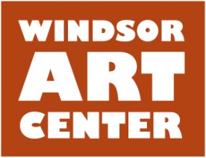

Press Release Contact: Wanda Seldon
Immediate 860-688-2528
May 19, 2016

Fiber art Workshops at Windsor Art Center

WINDSOR, CT –Windsor Art Center is offering two workshops this summer! The Art of Fabric Collage Workshop (back by popular demand) on Saturday, June 25 from 10 am-12 noon. Create original 8”X10” fabric art pieces through instruction on the use of value, color, and design. Also, Crazy Felted Beads! Workshop on Saturday July 9 • 10am – noon. Create these easy to make felted beads and be crazy about the results! They’re made of wool roving in a variety of colors, and the finished products can be strung to make a stunning necklace or bracelet, earrings or set of buttons. Please RSVP for workshops at 860-688-2528.
For a full description of this and other classes please go to www.windsorartcenter.org. For immediate information please call 860-688-2528 or email info@windsorartcenter.org. Discounts are available for Windsor Art Center Members.
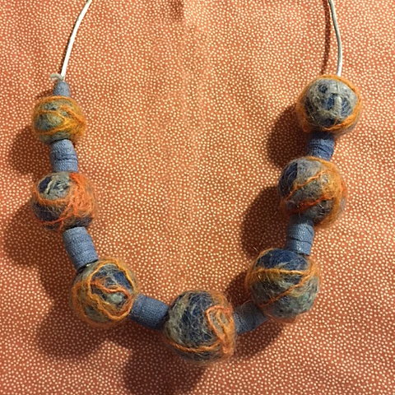
Photo

Located in Windsor, Connecticut, the Windsor Art Center is a nonprofit organization that promotes the visual and performing arts and presents visual art exhibits showcasing the works of a variety of artists working in diverse media and genres and hailing from throughout New England and beyond. Artist “talks” and children’s activities complete the annual programming. There is no charge to visit the gallery or the on-site gift shop which features locally made art. Parking is free and easily accessible. For more information on scheduled programs and exhibits, membership, and performing or exhibiting in the gallery, visit www.windsorartcenter.org.

