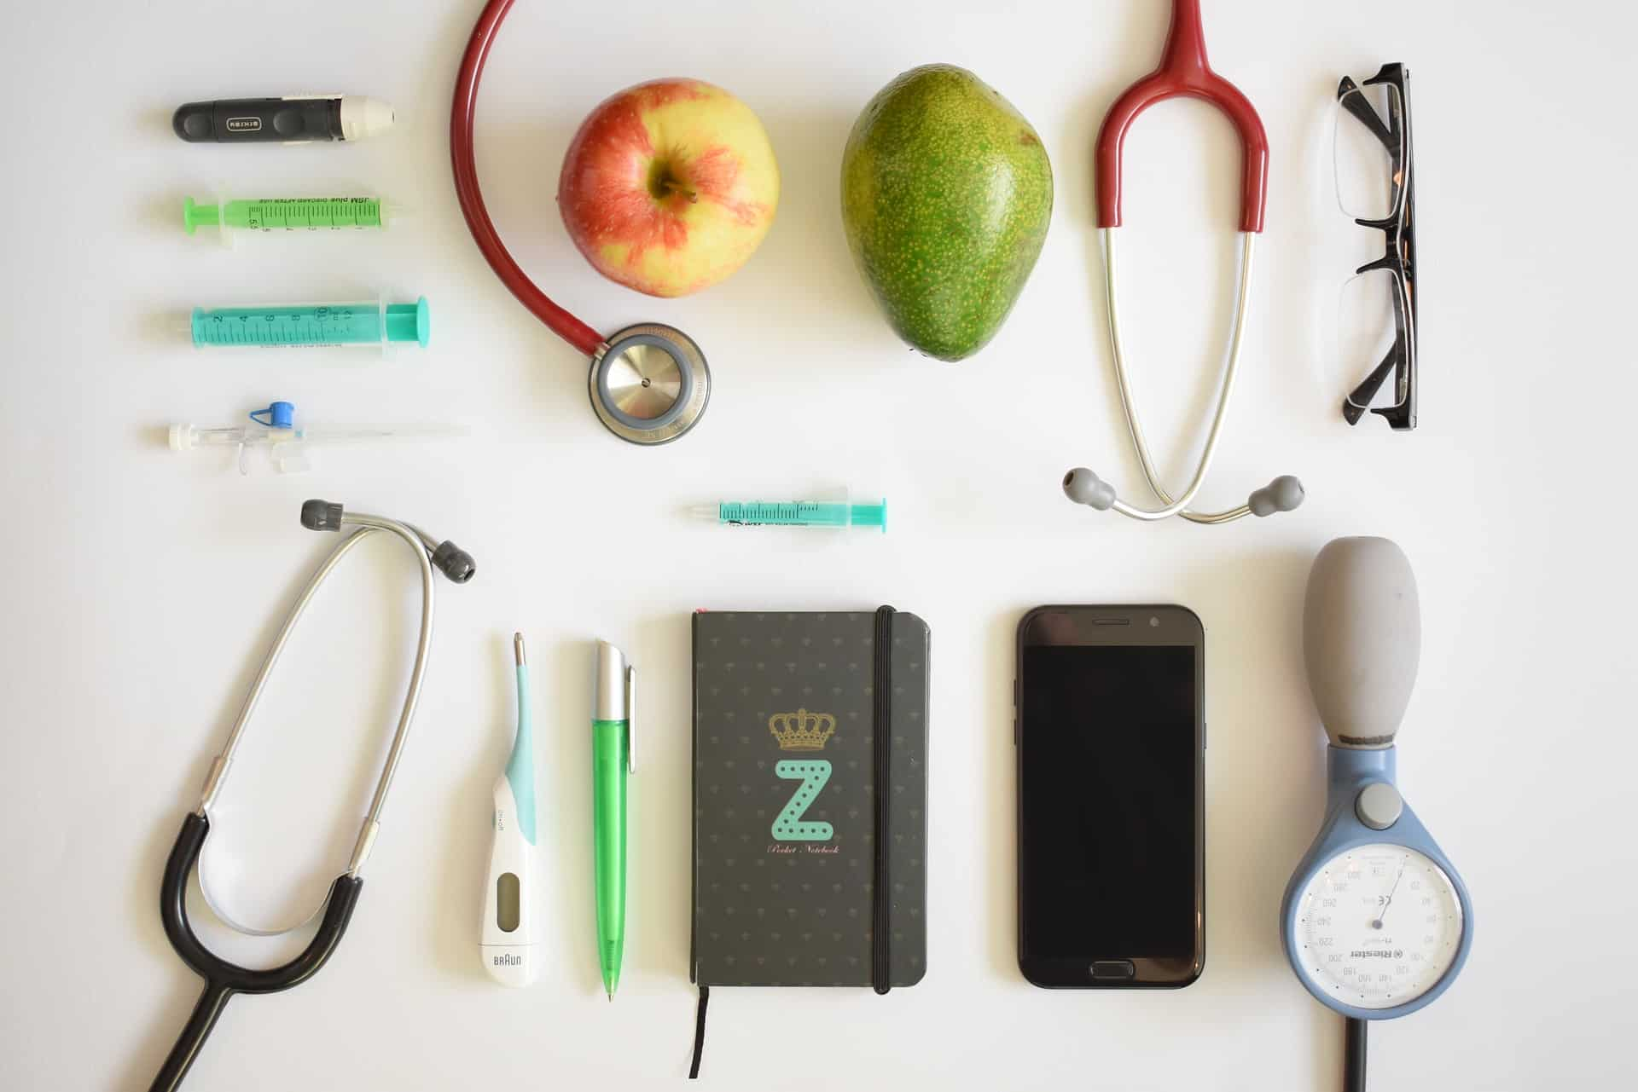
The Windsor Health Department is hosting a series of six Hypertension Workshops or High Blood Pressure Workshops. These workshops are scheduled over the summer and will be offered via Zoom. The dates and topics are listed below. In addition, each time you return the workshop evaluation and the Pre-Diabetes Risk Test, you will receive a $5 First Town Downtown Gift Card with a maximum of $30 awarded.

Workshop Schedule:

•6/14/21 Blood Pressure Classifications and Importance of Blood Pressure Control
Atique Mirza, MD
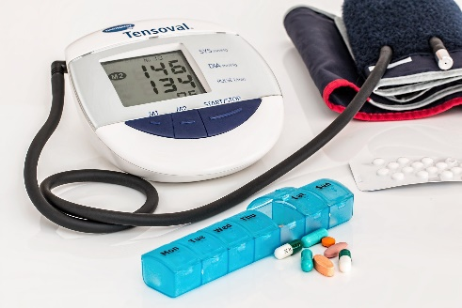
•6/28/21 Self-Measurement of Blood Pressure
Paula Raines LPN

•7/12/21 Lifestyle Modifications
Michelle Mattia RDN

•7/26/21 High Blood Pressure & Pharmacology
Kristen Marti PharmD

•8/23/21 Adherence to High Blood Pressure Therapy
Atique Mirza MD

•8/30/21 Hypertension Emergencies and Urgencies
Atique Mirza MD
Registration: Register on-line for the workshops listed above on the Town of Windsor website. They will be presented via Zoom. There is no charge to participate in these workshops

Time: 6:30 – 8:30pm.

Questions: Windsor Health Department at 860-285-1824

We look forward to having you join us!
