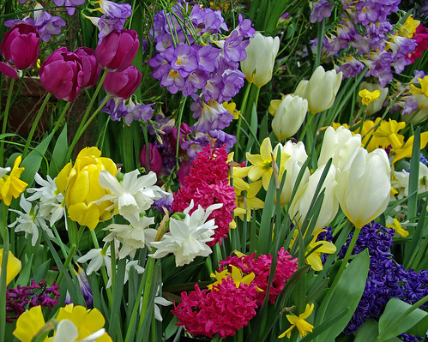

The Windsor Lions Club

“Symbol of Hope” Fundraiser
The Windsor Lions Club is sponsoring a “No Contact” Spring Bulb Fundraiser. Working with, “Bulbs for Change”, from Middlebury Vermont, the Lions offer Spring bulbs of the highest quality, that can be ordered online. These bulbs and plants come from all over the world, are 100% guaranteed, and will be delivered directly to your home in perfect time for planting.
Planted in the fall, these “symbols of hope” will bloom to brighten your garden and our community with a new beginning for Spring of 2023. One hundred percent of the proceeds from this fundraiser support Lions global causes, hunger, pediatric cancer, vision, the environment and diabetes. The Windsor Lions Club has been responsive to the needs of our community and beyond for 73 years.
For more information about the Windsor Lions Club, or with questions about this fundraiser, contact Lion Cindy Daniels, cldressage959@gmail.com
7
Symbol of Hope
Sale dates 08.12.2022 to 09.12.2022

